[**DESIGN PATTERNS AND PRINCIPLES**](https://github.com/Karthiga042/Cognizant-Java-FSE/tree/main/Week%201/Design%20Patterns%20and%20Principles)

**EXERCISE 2: IMPLEMENTING THE FACTORY METHOD PATTERN**

**Document.java**

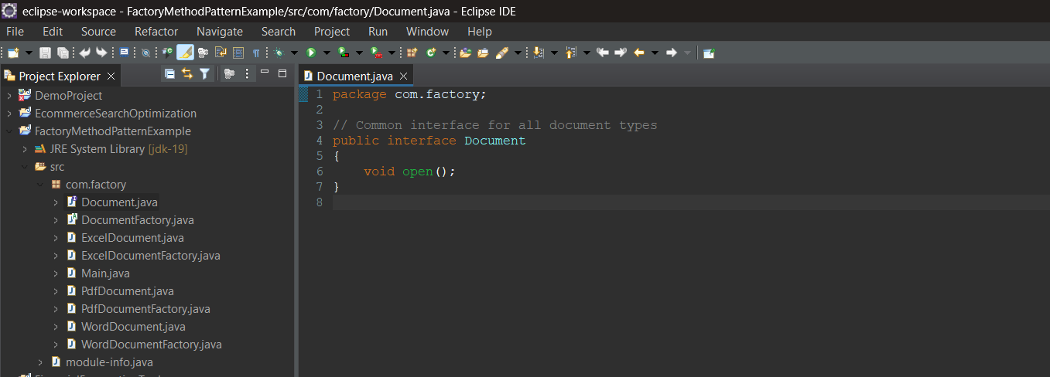

**DocumentFactory.java**

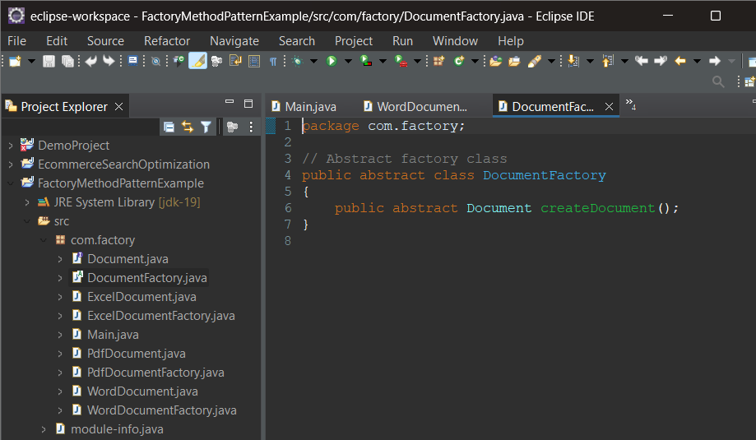

**ExcelDocument.java**

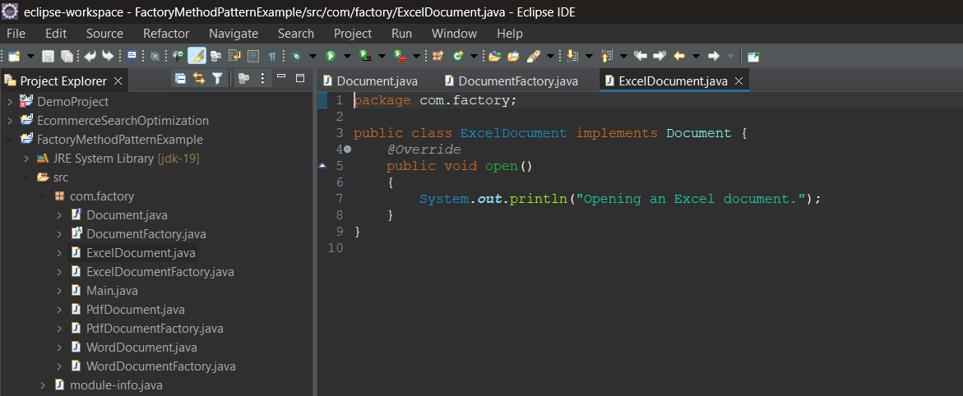

**ExcelDocumentFactory.java**

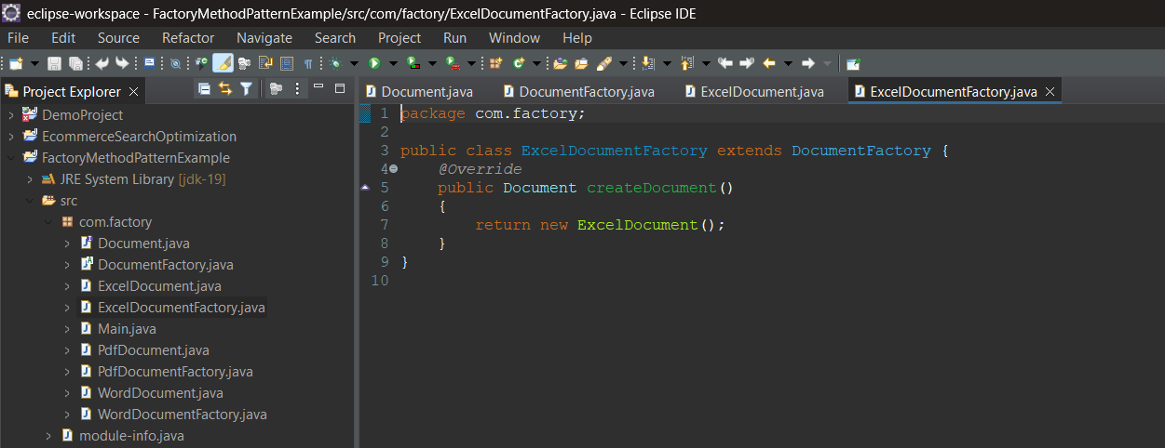

**PdfDocument.java**

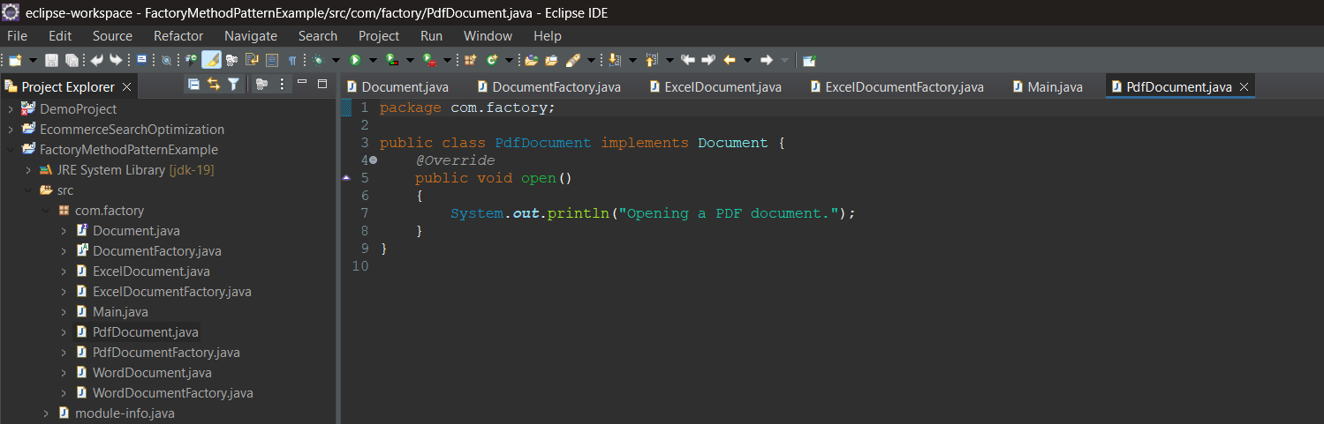

**PdfDocumentFactory.java**

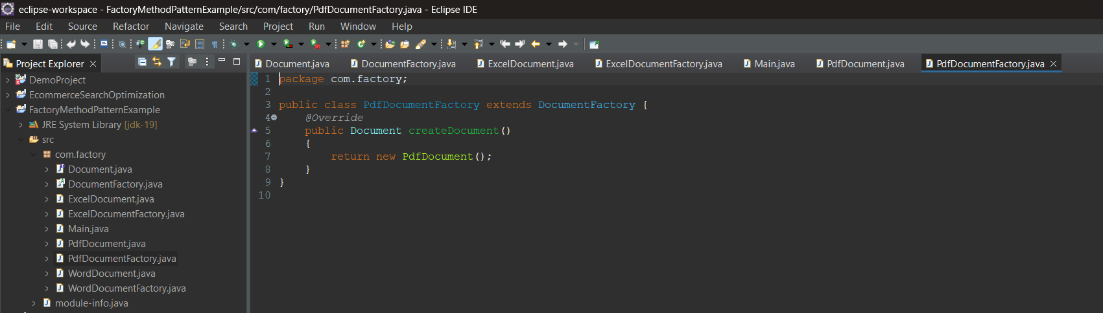

**WordDocument.java**

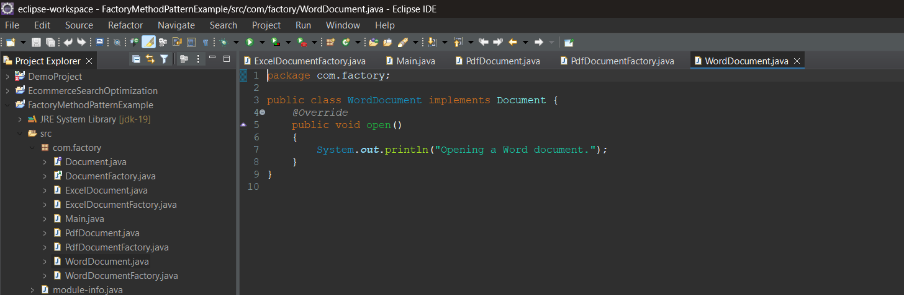

**WordDocumentFactory.java**

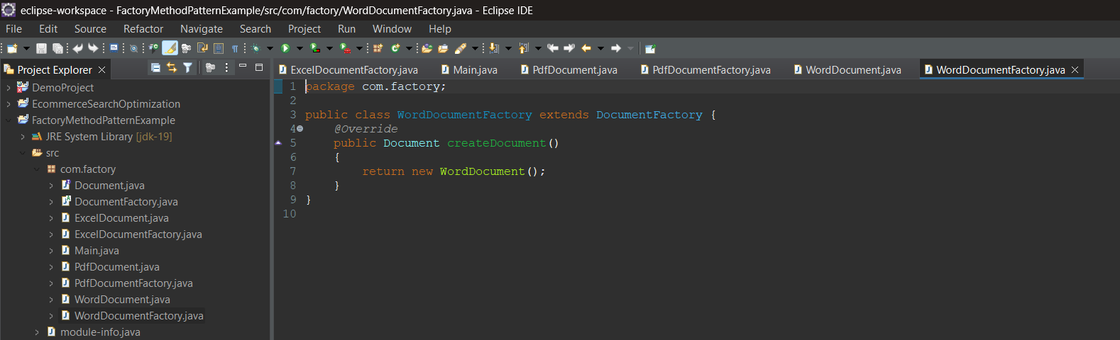

**Main.java**

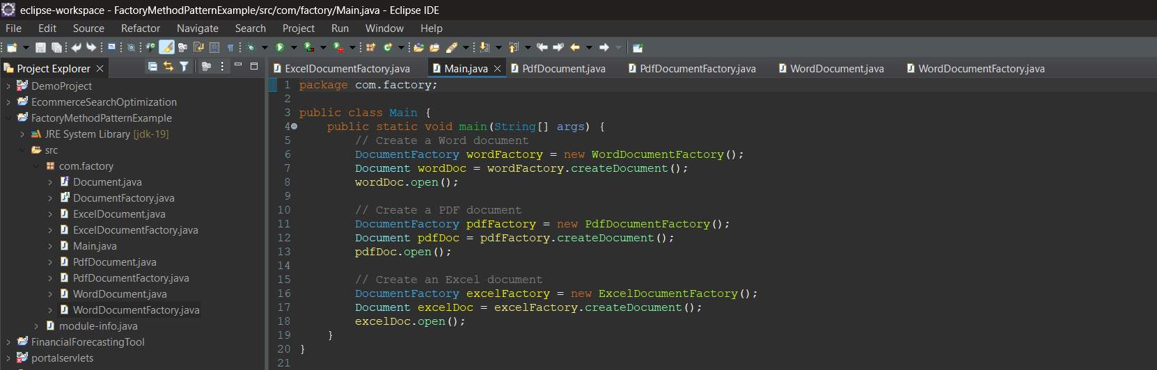

**Output:**

